**MULTITHREADING ASSIGNMENT-1**

1) Create and Run a Thread using Runnable Interface and Thread class and show usage of sleep and join methods in the created threads.

OUTPUT 1- Runnable Interface

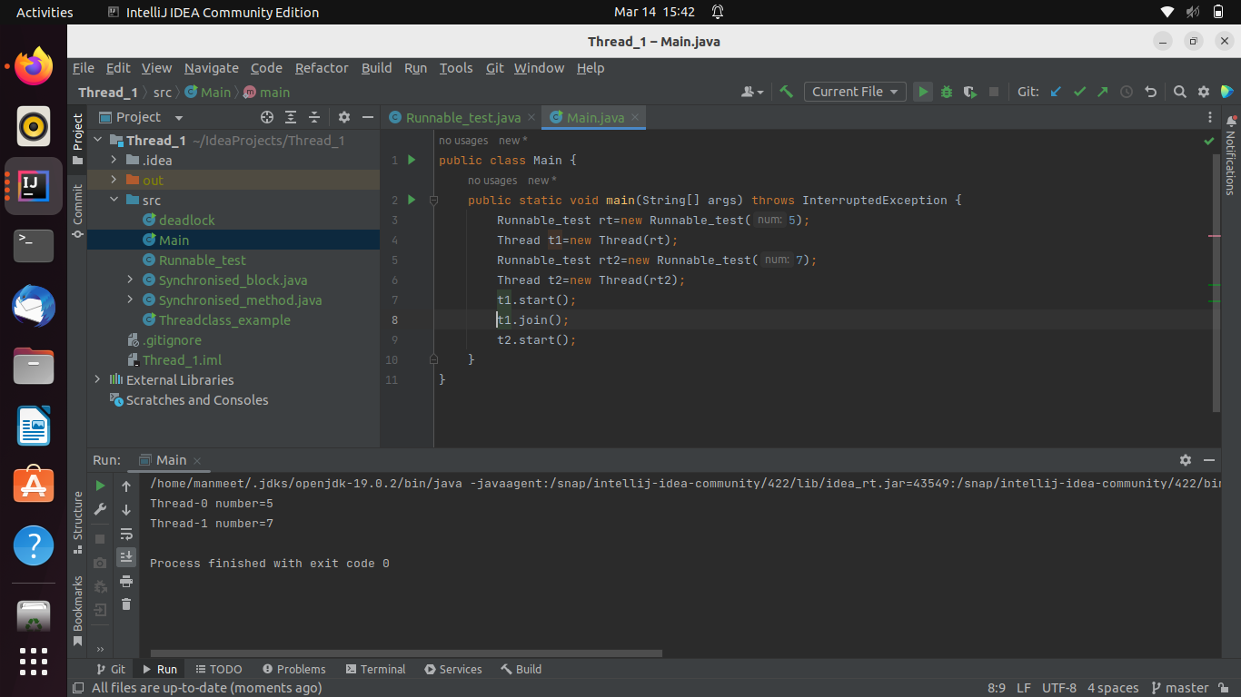

Thread class

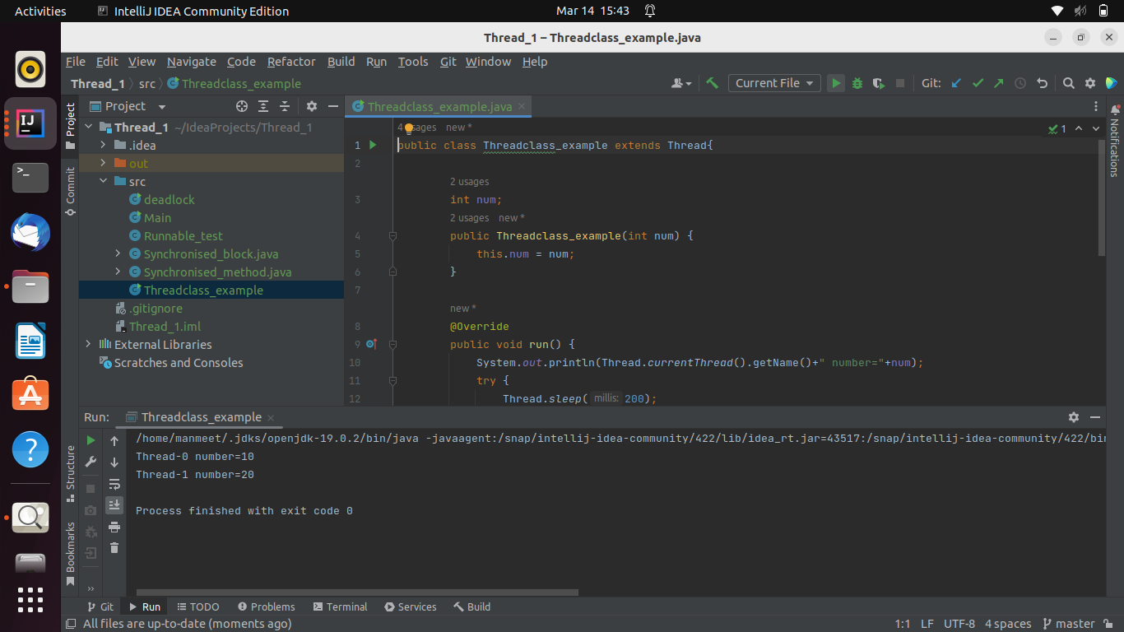

2) Use Synchronize method and synchronize block to enable synchronization between multiple threads trying to access method at same time.

OUTPUT 2- Synchronize method

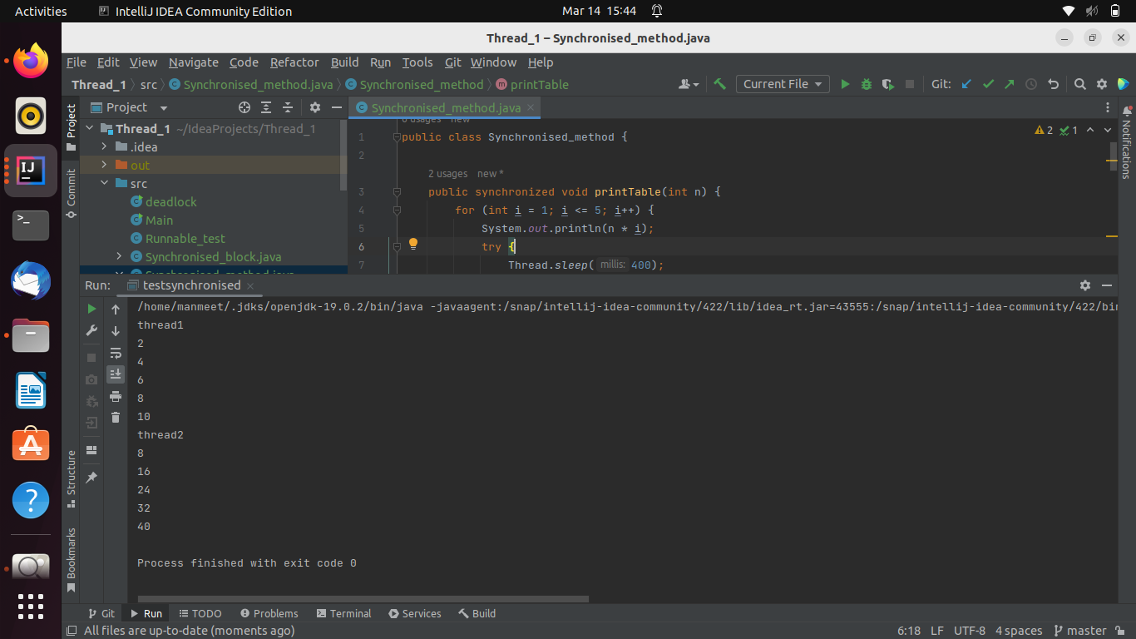

Synchronize block

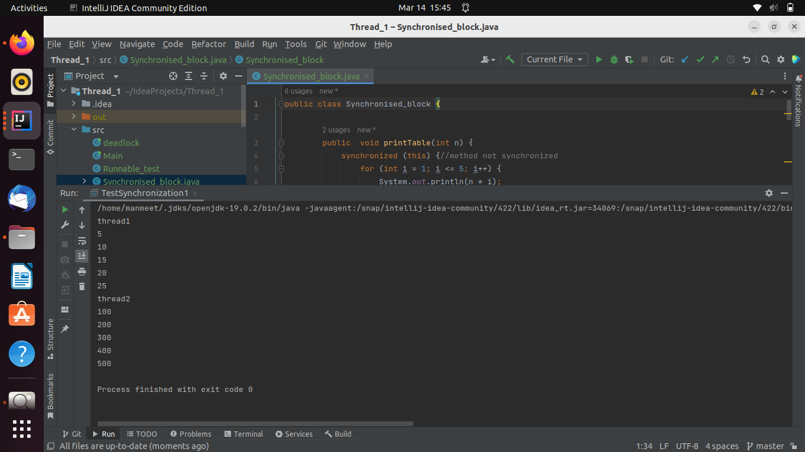

3) WAP to showcase the usage of volatile in java.

OUTPUT-3

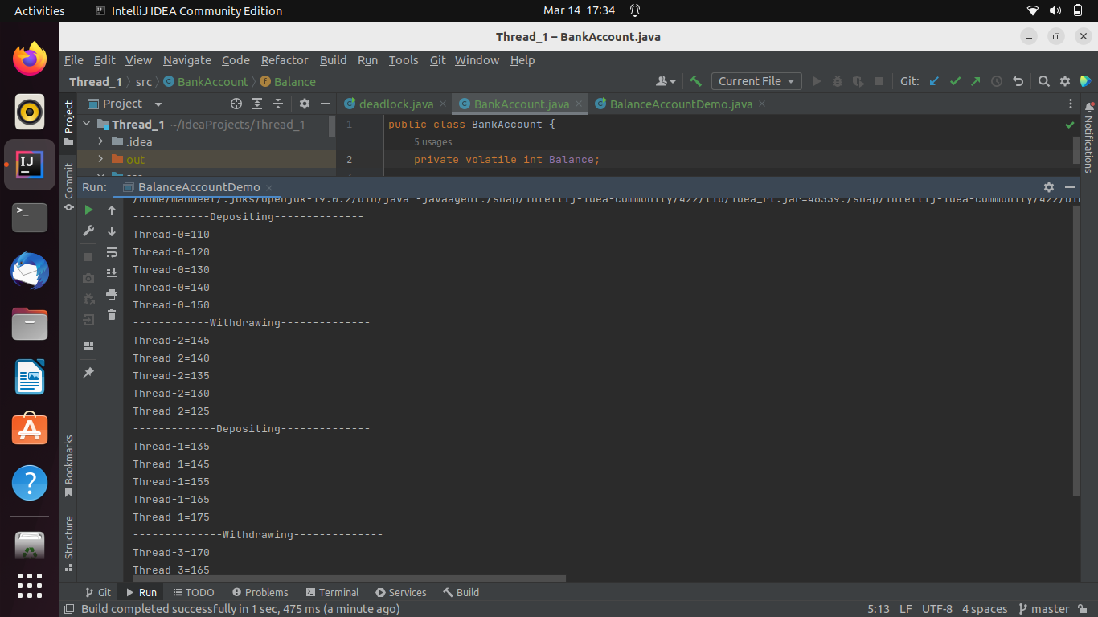

4) Write a code to simulate a deadlock in java

OUTPUT - 4

